How to derestrict a 48V 1000w Chaos Scooter

- Lift the deck.
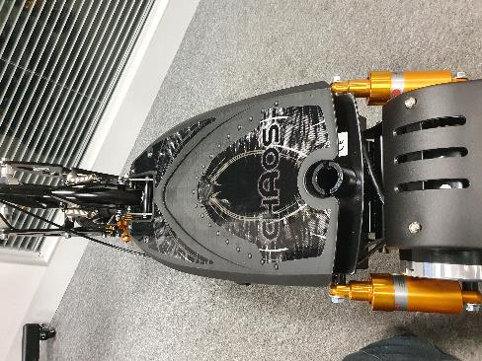
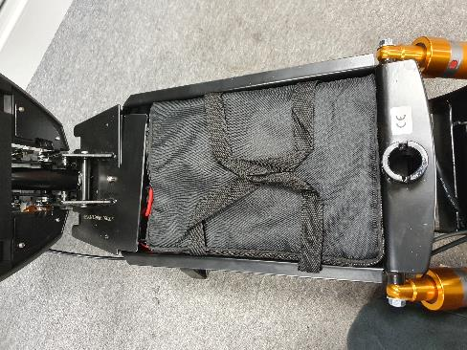

- Remove and disconnect the battery pack.
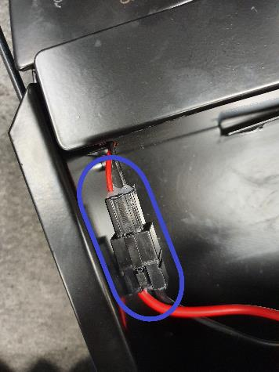
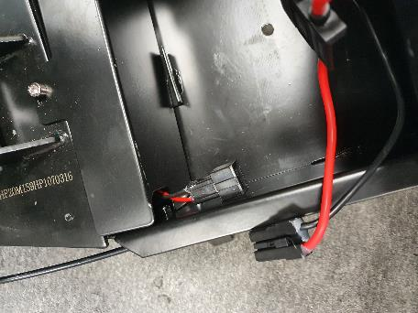

- Using a 5mm allen key remove the panel at the front of the scooter.
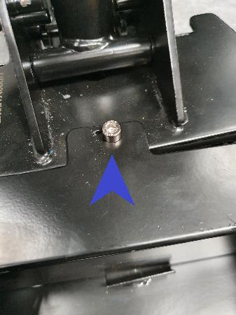

- Locate the single blue wire and disconnect.

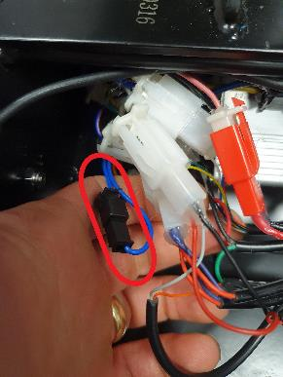

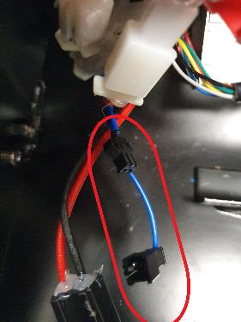

The scooter will now be derestricted, and the boost function will work.

12mph restricted with 72.5 kg rider
21mph unrestricted with 72.5kg rider

